**Informative Tittle:**

**Seed plant families with diverse mycorrhizal states have higher diversification rates**

**Authors:** María Isabel Mujica1,2\*, María Fernanda Pérez1,2, Gustavo Burin3 & Tiago Quental3

1Departamento de Ecología, Pontificia Universidad Católica de Chile, Santiago, Chile.

2Instituto de Ecología y Biodiversidad (IEB), Santiago, Chile.

3Departamento de Ecologia, Instituto de Biociências, Universidade de São Paulo, 11294, 05422-970 São Paulo, Brazil.

**Author for correspondence:** María Isabel Mujica (telephone: +56987671304, e-mail: mujisa@gmail.com)

**Words in the main body:** 3629

**Words for each section:** Introduction (776), Materials and Methods (1200), Results (468), Discussion (963), Acknowledgements (64)

**Number of figures:** 4

**Number of tables:** 1

**Supporting information:** 6 Tables and 1 Figure

**SUMMARY**

One crucial innovation in plant evolution was the association with soil fungi during land colonization. Today, this symbiotic interaction is present in most of plants species and can be classified in four types: Arbuscular (AM), Ecto (EM), Orchid (OM) and Ericoid Mycorrhiza (ER). Since the AM ancestral state, some plants lineages have switched partner (EM, OM and ER) or lost the association (no-association: NM). Evolutionary transitions to a novel mycorrhizal state (MS) might allow plant lineages to access new resources, enhancing diversification rates. However, some clades are not restricted to one MS, and this variability might promote diversification. In this study we address the relationship between MS and plant diversification rates of seed plant families. For this, we used the recently published FungalRoot database, which complied data for 14,870 species and their mycorrhizal partners. We assigned a single MS to each plant family, then calculated the heterogeneity of MS and estimated their diversification rates using the method-of-moments. Families with mixed MS had the highest diversification rates and there was a positive relationship between heterogeneity of MS and diversification rates. These results support the hypothesis that MS lability promotes diversification and highlight the importance of the association with soil fungi for the diversification of plants.

Keywords: *diversification rates, mycorrhizal states, seed plants, key innovation, mycorrhizal diversity*

**INTRODUCTION**

Understanding the basis of the exceptional plant diversity has been a matter of interest for ecologist and evolutionary biologist since Darwin. Great focus has been placed on estimating plants diversification rates and identifying the factors that could influence them (Eriksson & Bremer, 1992; Moore & Donoghe, 2007; O´Meara *et al*., 2016; Vamosi *et al.,* 2018). The acquisition of novel traits (sometimes referred to as “key innovations”), such as pollination by animals (Eriksson & Bremer, 1992) or physiological seed dormancy (Willis *et al.,* 2014), have been proposed to promote diversification of plant lineages. This “key innovation” perspective suggests that the acquisition of a novel trait might allow a given lineage to exploit the environment in a significantly different way, potentially resulting in an explosive radiation.

One crucial innovation in plants evolution was the association with soil fungi during land colonization (Pirozynski & Malloch, 1975; Selosse & Le Tacon, 1998; Strullu-Derrien *et al*., 2018). Before plant colonization, land was hostile, with extreme drought and temperatures, and barren rocky substrate; hence, the association with terrestrial fungi allowed the algae ancestors of plants to successfully colonize the land (Selosse *et al.,* 2015). This initial symbiotic association was the prelude of modern mycorrhizas (Feijen *et al.,* 2018), the association between fungi and root plants in which plants transfer carbon to fungi and receive nutrients in turn (Smith & Read, 2008). Today, this symbiosis is present in 86% of land plants species (van der Heijden *et al.,* 2015), and based on their structure and function can be classified in four major types: arbuscular mycorrhiza (AM), ectomycorrhiza (EM), orchid mycorrhizal (OM) and ericoid mycorrhizal (ER) (Brundrett, 2002).

Ancestral state reconstruction and the fossil record show that the ancestor of seed plants probably had AM associations (Redecker *et al.,* 2002; Maherali *et al.,* 2016). This is the most frequent mycorrhizal type in plants (74% of extant plant species) and is characterized by an association with Glomeromycete fungi (van der Heijden *et al.,* 2015). Between 100 and 200 million years ago, some lineages switched fungal partners to several lineages of Basidiomycetes, forming what is described as the EM associations (Brundrett, 2002). The acquisition of EM resulted in new root functional capabilities as freezing tolerance (Lehto *et al*., 2008), which seem related to the dominance of EM angiosperms and gymnosperm in cool forests (Brundrett, 2002). Similarly, Orchidaceae and species within the Ericaceae family recruited new fungal lineages and formed OM and ER associations respectively. Orchids associate with fungal families Ceratobasidiaceae, Tulasnellaceae and Sebacinaceae, which in addition to nutrient exchange, promote seed germination which cannot germinate without mycorrhizal support (Rasmussen, 2002). Ericoid mycorrhizal associations (ER), on the other hand, involve mainly fungi from Sebacinales and Helotiales and are mostly frequent under acidic and infertile heathland conditions (Perotto *et al.,* 2002; van der Heijden *et al*., 2015). Finally, some lineages have lost their mycorrhizal associations and became non-mycorrhizal (NM). This transition has frequently occurred through an intermediate state of facultative arbuscular mycorrhiza (AM) plants (Maherali *et al.,* 2016). Some of NM lineages evolved alternative resource-acquisition strategies (Werner *et al.,* 2018) like cluster-roots in Proteaceae (Neumann & Martinoia, 2002) or parasitism in Loranthaceae (Wilson & Calvin, 2006).

Therefore, since the AM ancestral state some plant lineages have followed different mycorrhizal evolutionary pathways: switching partner (EM, OM and ER) or losing the association (Werner *et al.,* 2018). Evolutionary transitions to a novel mycorrhizal state might allow plant lineages to access unexplored ecological resources, facilitating them to colonize environments that were not available before, and possibly enhancing their diversification rates. However, there are lineages in which some species acquire a new mycorrhizal state and at the same time, other species retain the ancestral state (AM) (Brundrett, 2008) increasing the variability of mycorrhizal states, which might in fact promote diversification of these lineages. Both hypotheses have not been evaluated in plants; however, the few studies available from the fungal perspective suggest that shifts in mycorrhizal associations might affect diversification of involved partners (Sánchez-García & Matheny, 2017; Sato *et al.,* 2017).

Even though mycorrhizal symbiosis has been pointed out as a key factor in the evolution and diversification of land plants (Brundrett & Tedersoo, 2018a; Feijen *et al.,* 2018) this has not been evaluated before. In this study we address the following questions: (1) Do the lineages that established derived mycorrhizal associations present higher diversification rates than the ones that retain the ancestral mycorrhizal state? This investigates the idea of a key innovation mechanism of diversification; (2) Is there a relationship between mycorrhizal variability and diversification rates among different plant lineages? This would investigate the idea that evolutionary lability might increase diversification dynamics. To answer these questions, we explored the relationship between the mycorrhizal state and the diversification rates of several seed plant families.

**MATERIALS AND METHODS**

*Mycorrhizal state database*

To obtain information of plant species and their mycorrhizal state, we used the FungalRoot database, a recently published global databank of plant mycorrhizal associations (Soudzilovskaia *et al.,* 2019). This database compiles previous lists and surveys of plant species and their mycorrhizal associations, including 36,303 records for 14,870 plant species. Additionally, based on these empirical records and on expert opinion, the authors proposed a list of mycorrhizal status at the plant genus level, which contains 14,541 genera which together results in information for 136,161 species.

Recently, Brundrett & Tedersoo (2018b) pointed out potential mistakes in mycorrhizal type identification on large databases, and how these misdiagnoses might lead to wrong conclusions. Although their approach used to determine these errors (taxonomic approach; Brundrett, 2017) is controversial (Bueno *et al.,* 2018; Bueno *et al*., 2019; Sun *et al*., 2019) and the proportion of errors they detected in databases is relatively low (Brundrett & Tedersoo, 2018), caution must be taken when analyzing large databases of plant mycorrhizal status. Therefore, in addition to the main analyses that were conducted using the genus-level list, we evaluated if the results were maintained when using only empirical data, by conducting the same analyses using the species-level list. Additionally, in the species-level list, the authors included remarks for 3,954 plant records (out of 36,303), indicating potential mistakes or misidentification of mycorrhizal associations in the original publication (see details in Table Media 3 in Soudzilovskaia *et al.,* 2019). Then, to test the effect of potential errors in the database, we conducted the analyses (i) excluding and (ii) without excluding plant records that had remarks (Section II of the supplementary material). Furthermore, to assess the effect of possible undetected errors in the genus-level dataset, we introduced errors to the mycorrhizal state of 20% of plant species (one order of magnitude higher than the error estimated from Brundrett & Tedersoo, 2018b). The results obtained with the error-introduced database and with the species-level list were similar than those derived from original data (Table S1).

*Family mycorrhizal state and diversity*

The genus-level list from FungalRoot database include information for genera belonging to 392 seed plant families. Before using this list, we prepared the data as follows (i) Typo correction: removed entries with spaces at the end, with double spaces or line breaks, (ii) matched genera to families using the table Spermatophyta\_Genera.csv, obtained from Zanne *et al*., (2014), (iii) Used package “taxize” from RStats to fill in for genera without family data and (iv) removed Ferns and Mosses. In the genus-level list, genera were classified as AM, EM, NM, OM, ER, or with multiple mycorrhizal status (i.e. AM-EM, AM-NM). Finally, the genera that were classified with multiple mycorrhizal status were classified as MIX, to indicate that these genera presented more than one mycorrhizal state. We obtained the richness of each genus from The Plant List (theplantlist.org), and then calculated the number of species with each mycorrhizal state within each family, discarding those genera that had unknown mycorrhizal type. Each family was assigned a unique mycorrhizal state (AM, EM, NM, ER or OM) when more than 60% of species sampled belonged to this mycorrhizal state. If no single state were present in more than 60% of species, the family was assigned a “MIX” state, to indicate no dominance of any mycorrhizal association. Other thresholds for the assignment of family mycorrhizal state were tested and the pattern was similar (50%, 80% and 100%, Table S2 and Fig. S1). However, we excluded from the analyses the families that all their species belonged to genera that were classified as MIX (only 18 families) given that in this case there is no direct information for any species about its specific mycorrhizal state (MS). Given our methodological choice to assign equal proportions of MS for those genera classified as MIX, that would, by definition, fix the absolute value of diversity index for all those families (see below). Given those genera only make up for the entirety of very few families (only 18 out of 392), we decided to simply remove those families from the analysis. To investigate the effect of mycorrhizal diversity in the diversification dynamics we estimated the “Mycorrhizal diversity index”, which is calculated by estimating the heterogeneity of the mycorrhizal states in each family using the shannon diversity index.

*Diversification rates*

First, to explore the underlying diversification model behind plant seed diversification, we assessed the correlation between age and richness among seed plant families. Thus, following Sanchez-Reyes *et al*., (2017), we evaluated the correlation between stem age and richness, including all seed plant families available (i.e. without removing families lacking information on mycorrhizal states) and correcting for phylogenetic structure and not. Stem group ages of the families were obtained from the dated molecular phylogeny of seed plants of Zanne *et al*., (2014) and the number of species of each family was obtained from The Plant List (theplantlist.org). No correlation was found between stem group age and richness, either considering or not phylogenetic structure (R2=0.009; R2=0.007, respectively; Fig.1), suggesting that diversification rates significantly vary among clades (Sanchez-Reyes *et al*., 2017) and justifying further investigation. Diversification rates for each seed plant family were estimated using the method-of-moments from Magallón & Sanderson (2001) and stem group ages. Because the relative contribution of extinction is unknown, we used two distinct scenarios to characterize the relative extinction rates (ε), one with no extinction, ε = 0.0 and another with high extinction, ε = 0.9. We are aware of more sophisticated and direct methods (e.g. BAMM; Rabosky, 2014) to investigate the association between trait states and diversification dynamics, but the plant phylogeny is massively under-sampled at the species level, and we clearly do not have mycorrhizal information for most species. Therefore, we decided to use simpler and less data hungry methods, and to discuss our results in the light of the methods limitations.

*Phylogenetic signal*

The seed plant phylogeny (Zanne *et al.,* 2014) was pruned to obtain a family level phylogeny, with one species per family as tips. From this pruned phylogeny we calculated the phylogenetic signal of mycorrhizal traits and diversification rates. For the continuous variables - mycorrhizal diversity index and diversification rates - we calculated phylogenetic signal using Pagel’s Lambda (Pagel, 1999) using the function phylosig in the package phytools in R (Revell, 2012). For the categorical variable, mycorrhizal state, we estimated the phylogenetic signal using the D parameter (Fritz & Purvis, 2010) with the function phylo.d in caper package in R (Orme *et al.,* 2013).

*Statistical analysis*

As some (but not all) of the mycorrhizal traits and diversification rates showed significant phylogenetic signal (Table S3), we evaluated the effect of mycorrhizal associations on diversification rates by both considering and not the phylogenetic structure in the residuals. We tested for potential differences in diversification rates between plant families with different mycorrhizal types using both ANOVA and a phylogenetic ANOVA using the function phylanova from phytools in R. Each mycorrhizal state was used as group and their diversification rates as response variable. Because the mycorrhizal states OR and ER only had one family each, those were removed from this analysis.

To test for the relationship between mycorrhizal heterogeneity and diversification rates we performed a linear model with raw data, and a PGLS regression in the R package caper (Orme *et al.,* 2013) with diversification rates as response variable and mycorrhizal heterogeneity as explanatory variable. For PGLS models we used the lambda value obtained from the previous phylogenetic signal analysis. To further explore the potential confounding effect and the association between mycorrhizal association and diversification dynamics, we performed PGLS regressions to assess the relationship between mycorrhizal diversity index, age and species richness.

**RESULTS**

The genus-level list from FungalRoot database contained information about mycorrhizal state of 136,161 species that belong to 392 families of seed plants. We did not remove any family due to poor sampling since all families have either at least 58.3% of total richness or at least 8 species sampled, but we had to exclude 23 MIX families due to inability to assign their species to a given mycorrhizal state (See Materials & Methods). According to our classification, 273 families were AM (for example, Amaryllidaceae, Asteraceae and Lamiaceae), 9 were EM (as Fagaceae, Nothofagaceae, Betulaceae and Pinaceae), 37 were NM (such as Brassicaceae and Caryophyllaceae) and 48 were mixed (Fig. 2). Mixed families contain species that retained the ancestral state (AM) and species that present a different mycorrhizal state (EM or NM). There were three different types of mixed families: 41 mixed families had AM and NM species (such as Amaranthaceae, Bromeliaceae, Portulacaceae and Montiaceae), four had AM and EM species (Casuarinaceae, Hydrocharitaceae, Juglandaceae and Salicaceae) and three had AM, EM and NM (Goodeniaceae, Nyctaginaceae and Polygonaceae). The phylogenetic signal strength differs among mycorrhizal types. While AM and EM are mostly spread randomly across the plant phylogeny, NM and MIX are phylogenetically clustered to some extent (Table S3). Likewise, the phylogenetic signal of diversification rates was significantly different from a random structure in r*ɛ=0.0* but not in r*ɛ=0.9* (Table S3). There was a significant difference in diversification rates between the mycorrhizal states, irrespective of the extinction scenario (r*ɛ=0.0* F= 13.25, P=0.001; r*ɛ=0.9* F= 12.18, P=0.002; Fig. 3a and 3b), which was observed in the ANOVA and in the phylogenetic ANOVA (Table S4). The *a posteriori* analysis of the ANOVA showed that diversification of MIX families was significantly higher than that of AM, EM and NM families and the same tendency is observed when correcting for the phylogenetic structure (Table S5).

The higher values of mycorrhizal diversity index were found in Rhizophoraceae (0.726), Nyctaginaceae (0.693) and Plumbaginaceae (0.692), while the lowest value was zero and it was observed in 275 families that have all species in the same mycorrhizal state, like in Pinaceae (EM, n=255), Araucariaceae (AM, n=38) and Droseraceae (NM, n=189). There was a positive association between mycorrhizal diversity index and diversification rates, observed with the linear models and with the PGLS (Figure 4a and 4c). The significant relationship is observed under the two different scenarios of extinction (r2 with the p-values of the models are shown in Table 1). Mycorrhizal diversity index had no correlation with age and a significant but very low correlation with species richness (r2 = -0.002 and 0.01, respectively; Fig. 4d, 4d).

**All additional analyses (at the species level and adding a Mycorrhizal misidentification to 20% of the species) support our main conclusions (Mix families had higher diversification rates; positive association between** mycorrhizal diversity index and diversification rates) **and hence are only shown at the supplemental material.**

**DISCUSSION**

The association with mycorrhizal fungi has been indicated as a key acquisition in the evolution of plants, nevertheless its effect on plants diversification has not been evaluated before. Here we presented the first attempt to assess the relationship between mycorrhizal associations and diversification rates of plants. Due to the under-sampling of seed plants phylogeny and mycorrhizal state database, we used a simple and conservative approach that allows us to tackle this question.

Our results showed that there was no difference on diversification rates between AM, EM and NM families (Fig. 3; Table S5). This shows that families that acquired novel mycorrhizal associations (EM and NM) do not have higher diversification rates than families that retained the ancestral state (AM), contrary to what was expected in a scenario of key innovation in mycorrhizal associations as a mechanism of diversification. Thus, regarding our first question, the lineages that established derived mycorrhizal associations do not differ in their diversification rates from AM families. Contrary, our analyses showed that families with mixed mycorrhizal state have higher diversification rates than AM, EM and NM families (Fig. 3, Table S5). Mixed strategy included three subtypes of mixed: families with AM and NM species, families with AM and EM species and families with AM, EM and NM species; the three subtypes had higher diversification rates and there was no significant difference on rates between them. This shows that regardless of the mycorrhizal states that composed the mixed families, they have the highest diversification rates, suggesting that it is the diversity of mycorrhizal states that promotes diversification rather than a specific mycorrhizal state.

In addition, there was a positive and significant association between mycorrhizal diversity index and diversification rates, which does not depend on our categorical criteria of mycorrhizal state assignment to families. These associations with diversification rates, are observed when correcting or not for the phylogenetic structure, suggesting that the relationship is not due to phylogenetic relatedness between families. Also, the patterns are observed under different scenarios of extinction, and even with ε=0.9, where extinction could have an important role, the relationship is conserved. Given that diversification rates are determined by age and richness of the family, the effect of those variables could have driven the relationship between mycorrhizal heterogeneity and diversification rates. We observed no significant correlation between mycorrhizal heterogeneity and age; and we see a similar pattern with species richness, although the correlation is significant, the r2 is quite low (Fig. 4b, 4d). This supports that mycorrhizal heterogeneity is mainly associated with diversification rates, not with age or richness per se. In addition, these patterns are also observed when we analyzed the species-level data (Supplementary Material Section II).

Both results, the ANOVA for family mycorrhizal type and association between mycorrhizal heterogeneity and diversification, suggest that independent of which mycorrhizal state is involved, a higher heterogeneity of mycorrhizal states in a family might promote diversification rates. We interpret mycorrhizal heterogeneity as a result from a higher evolutionary lability of the mycorrhizal states within these families, which has been suggested to promote diversification in other biotic interactions (Hardy & Otto, 2014). Each mycorrhizal state provides advantages to plants in certain environments but not in others (Brundrett *et al.,* 2002), thus families that are composed by species with different mycorrhizal states might have been able to switch states in evolutionary time, making them able to evolve a higher diversity of niches which would result in a higher diversification rate. Under this scenario, mycorrhizal diverse families would have had more chances to take advantage of a new ecological opportunity, than families with most species within a single mycorrhizal state. It is interesting to note that mycorrhizal diverse families have not only higher diversification when compared to low diverse families with the ancestral state, but also higher rates than families that have switched from the ancestral state to one novel mycorrhizal state (NM and EM families).

The mycorrhizal diversity index might not capture well the effects of mycorrhizal shifts on diversification rates if shifts occurred only once within each family. However, we observed that mycorrhizal shifts in mix families occurred multiple times, because more than 97% of mixed families contain genera that have multiple mycorrhizal states, this means that the MS do not form monophyletic sub-clades and shifts occur even below the genus level. This suggests that diversification rates are not the result of a single mycorrhizal shift, but a result of high lability of the mycorrhizal types within the mixed families. These results together suggest that rather than a key innovation scenario, it is the evolutionary variability of mycorrhizal state what promotes diversification rates of plant seed families. Our results also highlight the evolutionary role of specialization at different organization levels: even if species are mycorrhizal specialized within a mixed family, the possibility to switch to different mycorrhizal states might increase the diversification of the family.

Because biodiversity dynamics could be rather complex, with clades either expanding, at equilibrium and even declining in diversity, simple metrics like the average rate of diversification might not be able to separate them (Quental & Marshall, 2010). The use of an average rate as a descriptor of a clade diversification dynamics assumes (or at least equates to) a scenario of expanding diversity (Quental & Marshall, 2010), and it might be especially problematic if lineages have a carrying capacity because the average rate might be diluted as time goes by (Rabosky, 2009). Moreover, with an average rate is not possible to distinguish between speciation and extinction rates or to test directly the effect of one trait on diversification dynamics. Ideally one would use more complex tests, but that would require a lot more phylogenetic data than what is currently available. Additionally, the ecological data is scarce, and the identification of root associations might be complicated by inconsistent applications of definitions (Brundrett, 2008). Thus, our study points out the need for more accurate ecological knowledge on plants species and their mycorrhizal state. Overall, we used a relatively simple and limited macroevolutionary method and our conclusions arose from a limited ecological and phylogenetic data. These conclusions might be revisited in future studies, when more data on mycorrhizal states and more complete phylogenies of plants are available.

Acknowledging the limitations of our study, the results suggest that a higher diversity of mycorrhizal strategies promotes diversification of lineages, possibly related with new ecological opportunities that each mycorrhizal state provides to plants. Our results finally suggest that the associations between soil fungi and plants has been key for plant diversification, not only due to the foundational association that allows plants colonize land (Pirozynski & Malloch, 1975) but also for further diversification of seed plant lineages.

**ACKNOWLEDGEMENTS**

We thank all members of the Lab MeMe in the Institute of BioScience at the University of São Paulo for discussions and suggestions; and Guillermo Bueno for his contribution to the database. T.B.Q. thanks FAPESP for financial support (grants # 2012/04072-3 and #2018/05462-6), G. B. thanks FAPESP for financial support (grant # 2018/04821-2) and M.IM. thanks CONICYT for the doctoral scholarship # 21151009.

**AUTHOR CONTRIBUTIONS**

MIM, TQ and MFP designed the research; MIM collected the data, GB, MIM and TQ analyzed the data, GB made the figures; and all the authors wrote the manuscript.

**REFERENCES**

**Boyle, B. et al. 2013.** The taxonomic name resolution service: an online tool for automated standardization of plant names. *BMC Bioinformatics* 14:16. doi:10.1186/1471-2105-14-16

**Brundrett MC. 2002.** Tansley Review No. 134. Coevolution of roots and mycorrhizas of land plants. *New Phytologist* **154**: 275-304.

**Brundrett MC. 2008.** Mycorrhizal Associations: The Web Resource. Date accessed. ‹mycorrhizas.info›.

**Brundrett MC. 2017.** Global diversity and importance of mycorrhizal and nonmycorrhizal plants. In: Tedersoo L (ed) Biogeography of mycorrhizal Symbiosis. Springer International Publishing, Cham, pp 533–556

**Brundrett MC, Tedersoo L. 2018a.** Evolutionary history of mycorrhizal symbioses and global host plant diversity. *New Phytologist*, doi:10.1111/nph.14976.

**Brundrett MC, Tedersoo L. 2018b.** Misdiagnosis of mycorrhizas and inappropriate recycling of data can lead to false conclusions. *New Phytologist*,https://doi.org/10.1111/nph.15440

**Bueno CG, Gerz M, Zobel M, Moora M. 2018.** Conceptual differences lead to divergent trait estimates in empirical and taxonomic approaches to plant mycorrhizal trait assignment. *Mycorrhiza* https://doi.org/10.1007/s00572-018-0869-1

**Eriksson O, Bremer B. 1992.** Pollination Systems, Dispersal Modes, Life Forms and Diversification Rates in Angiosperm Families. *Evolution* **46**: 258-266.

**Feijen FAA, Vos RA, Nuytinck J, Merck VSFT. 2018.** Evolutionary dynamics of mycorrhizal symbiosis in land plant diversification. *Scientific Reports* doi:10.1038/s41598-018-28920-x.

**Fritz SA, Purvis A. 2010.** Selectivity in mammalian extinction risk and threat types: a new measure of phylogenetic signal strength in binary traits. *Conservation Biology* **24**: 1042-1051.

**Hardy NB, Otto SP. 2014.** Specialization and Generalization in the Diversification of Phytophagous Insects: Tests of the Musical chairs and Oscillation hypotheses. *Proceedings of the Royal Society B–Biological Sciences***281**: 20132960.

**Lehto T, Brosinsky A, Heinonen-Tanski H, Repo T. 2008.** Freezing tolerance of ectomycorrhizal fungi in pure culture. *Mycorrhiza* **18**: 385–392.

**Maherali H, Oberle B, Stevens PF, Cornwell WK, McGlinn DJ. 2016.** Mutualism persistence and abandonment during the evolution of the mycorrhizal symbiosis. *The American Naturalist* **188**: E113–E125.

**Magallón S, Sanderson MJ. 2001.** Absolute Diversification rates in Angiosperm clades. *Evolution* **55**:1762–1780.

**Moen DS, Wiens JJ. 2017.** Microhabitat and Climatic Niche Change Explain Patterns of Diversification among Frog Families. *The American Naturalist* **190**: 29-44

**Moore B, Donoghe MJ. 2007.** Correlates of Diversification in the Plant Clade Dipsacales: Geographic Movement and Evolutionary Innovations. *The American Naturalist* **170**: 28-55.

**Neumann G, Martinoia E. 2002.** Cluster roots – an underground adaptation for survival in extreme environments. *TRENDS in Plant Science* **7**: 162-167.

**O´Meara BC, Smith SD, Armbruster WS, Harder LD, Hardy CR, Hileman LC, Hufford L, Litt A, Magallón S, Smith SA (2016)** Non-equilibrium dynamics and floral trait interactions shape extant angiosperm diversity. *Proceedings of the Royal Society B–Biological Sciences* **B283**: 20152304.

**Orme CDL, Freckleton RP, Thomas GH, Petzoldt T, Fritz SA, Isaac N. 2013.** CAPER: comparative analyses of phylogenetics and evolution in R. Methods in *Ecology and Evolution* **3**: 145-151.

**Pagel M. 1999.** Inferring the historical patterns of biological evolution. *Nature* **401**: 877-884.

**Perotto S, Girlanda M, Martino E. 2002.** Ericoid mycorrhizal fungi: some new perspectives on old acquaintances. *Plant and Soil* **244**: 41–53.

**Pirosynski KA, Maloch DW. 1975.** The origin of land plants: A matter of mycotrophism. *Biosystems* **6**: 153-164.

**Quental, TB, Marshall CR. 2010.** Diversity dynamics: molecular phylogenies

need the fossil record. *Trends in Ecology and Evolution* **25**: 434–441.

**Rabosky DL. 2009.** Ecological limits and diversification rate: alternative paradigms to explain the variation in species richness among clades and regions. *Ecology Letters* **12**:735–43.

**Rabosky, DL. 2014.** Automatic detection of key innovations, rate shifts, and

diversity-dependence on phylogenetic trees. *PLoS ONE* **9**: e89543.

**Rasmussen HN. 2002.** Recent developments in the study of orchid mycorrhiza. *Plant and Soil* **244**: 149–163.

**Redecker D, Kodner R, Graham LE. 2002.** Glomalean fungi from the Ordovician. *Sience* **289**: 1920-1921.

**Revell LJ. 2012.** phytools: An R package for phylogenetic comparative biology (and other things). *Methods in Ecology and Evolution* **3**: 217-223.

**Stadler T, Rabosky DL, Ricklefs RE, Bokma F. 2014.** On Age and Species Richness of Higher Taxa. *The American Naturalist*, 184: 447–455

**Sánchez-García M, Matheny PB. 2017.** Is the switch to an ectomycorrhizal state an evolutionary key innovation in mushroom-forming fungi? A case study in the Tricholomatineae (Agaricales). *Evolution* **71**: 51–65

**Sánchez-Reyes LL, Morlon H, Magallón S. 2017.** Uncovering Higher-Taxon Diversification Dynamics from Clade Age and Species-Richness Data. *Systematic Biology* **66**:367–378.

**Sato H, Akifumi ST, Hitozaku T. 2017.** Host shifts enhance diversification of ectomycorrhizal fungi: diversification rate analysis of the ectomycorrhizal fungal genera Strobilomyces and Afroboletus with an 80-gene phylogeny. *New Phytologist* **214**: 443–454.

**Selosse MA, Le Tacon F 1998.** The land flora: A phototroph–fungus partnership? *TREE* 13: 15-19.

**Selosse MA, Strullu-Derrien C., Martin FM, Kamoun S, Kenrick P. 2015.** Plants, fungi and oomycetes: a 400-million years affair that shapes the biosphere. *New Phytologist* **206**: 501–506

**The Taxonomic Name Resolution Service [Internet]. iPlant Collaborative.** Version 4.0 [Accessed:04 May 2018]. Available from: http://tnrs.iplantcollaborative.org.

**Smith SE, Read DJ. 2008.** Mycorrhizal symbiosis. Cambridge, UK: Academic Press.

Sun T, Zhang H, Wang Z. 2019. Reply to Tedersoo et al.: Plant species within the same family or genus can have different mycorrhizal types? *Proceedings of the National Academy of Science* 116:12141-12142

**Vamosi J, Magallón S, Mayrose I, Otto SP, Sauquet H. 2018. Macroevolutionary** Patterns of Flowering Plant Speciation and Extinction. *Annual Review of Plant Biology* **69**:9.1–9.22

**van der Heijden MGA, Martin FM, Selosse MA, Sanders I. 2015.** Mycorrhizal ecology and evolution: the past, the present, and the future. *New Phytologist* **205**: 1406-1423.

**Werner GDA, Cornelissen JHC, Cornwell WK, Soudzilovskaia NA, Kattge J, West SA, Kiers ET. 2018.** Symbiont switching and alternative resource acquisition strategies drive mutualism breakdown. *Proceedings of the National Academy of Sciences, USA* **115**: 5229-5234.

**Willis CG, Baskin CC, Baskin JM, Auld JR, Venable DL, Cavender-Bares J, Donohue K, Rubio de Casas R, The NESCent Germination Working Group. 2014.** The evolution of seed dormancy: environmental cues, evolutionary hubs, and diversification of the seed plants. *New Phytologist* **203**: 300–309.

**Wilson CA, Calvin CL. 2006.** An origin of aerial branch parasitism in the Mistletoe family, Loranthaceae. *American Journal of Botany* **93**: 787–796.

**Zanne AE, Tank DC, Cornwell WK, Eastman JM, Smith SA, FitzJohn RG, McGlinn DJ, O´Meara BC, Moles AT, Reich PB et al. 2014.** Three keys to the radiation of angiosperms into freezing environments. *Nature* **506**:89–92.

**SUPPORTING INFORMATION**

Additional Supporting Information may be found online in the Supporting Information tab for this article:

**Fig. S1.** Relationship between mycorrhizal type and diversification rate estimated with ε= 0 and with ε= 0.9, using different filters for MIX state assignment.

**Table S1.** Relationship between family mycorrhizal type (ANOVA), mycorrhizal diversity index (linear model) and diversification rates, using a modified dataset that contains 20% of randomly selected species with wrong mycorrhizal state assignation.

**Table S2.** Summary of ANOVAs between mycorrhizal type and diversification rate using different thresholds for mycorrhizal type assignation.

**Table S3.** Phylogenetic signal of mycorrhizal traits and diversification rates **Table S4.** Results of ANOVA and phylogenetic ANOVA between mycorrhizal type and diversification rate. **Table S5.** *A posteriori* analysis of ANOVA and phylogenetic ANOVA

**Table S6.** Seed plant families included in the analyses, % of species with each mycorrhizal state (AM, arbuscular mycorrhiza; EM, ectomycorrhiza and NM, non-mycorrhizal), family mycorrhizal state, diversification rates and mycorrhizal diversity index.

**FIGURE LEGENDS**

**Figure 1.** Relationship between number of species and age for each lineage when compared to the confidence intervals based on the global diversification rate of seed plants. The solid and dashed lines represent the expected richness for epsilon = 0 and epsilon = 0.9, respectively. The color of the points represents the mycorrhizal state for the 60% threshold.

**Figure 2.** Family-level, time-calibrated phylogeny for the 367 seed plant families included in the analyses. For each family, the proportion of species within each mycorrhizal type is represented in the rose-to-red boxes, AM: Arbuscular mycorrhiza, EM: Ectomycorrhiza and NM: non-mycorrhizal. The mycorrhizal diversity index (MDI) is represented in the purple boxes and the diversification rates (r) are shown in the green boxes. To illustrate the timescale of the phylogeny, the width of concentric white and gray circles represents 100 million years.

**Figure 3.** Relationship between mycorrhizal type and diversification rates. a) diversification rate estimated with ε (relative extinction fraction) = 0 and b) diversification rate estimated with ε= 0.9. AM: Arbuscular mycorrhiza, EM: Ectomycorrhiza, NM: non-mycorrhizal and MIX (families with no dominance of any specific mycorrhizal association). The size of the points indicates the Mycorrhizal Type Diversity Index value for each lineage, indicating a predominance of larger indices with higher diversification rates.

**Figure 4.** Scatterplots showing the relationship between mycorrhizal diversity index and diversification rates (a and c), species richness (b) and age family (d). Diversification rates were estimated with ε (relative extinction fraction) = 0 (a) and with ε= 0.9 (c). The red and blue lines indicate the results of a linear model and a phylogenetic generalized least squares (PGLS) fit, respectively.

**Table 1**. Summary of PGLS and linear model (LM) between mycorrhizal diversity index (predictor variable) and diversification rate (response variable), for each of the estimated diversification rates analyzed separately. ε is the relative extinction fraction used for the estimation of diversification rate, and lambda is the estimated phylogenetic signal of the PGLS.

|  |  |  |  |  |  |
| --- | --- | --- | --- | --- | --- |
| Diversification rates | Fitting LM for Mycorrhizal diversity index | | Fitting PGLS for Mycorrhizal diversity index | | |
|  | P-value | r2 | P-value | r2 | lambda |
| r*ɛ=0.0* | 5.10E-15 | 0.1535 | 1.89E-12 | 0.1264 | 0.467 |
| r*ɛ=0.9* | 3.53E-15 | 0.1551 | 4.45E-13 | 0.1333 | 0.355 |

**Figure 1.**

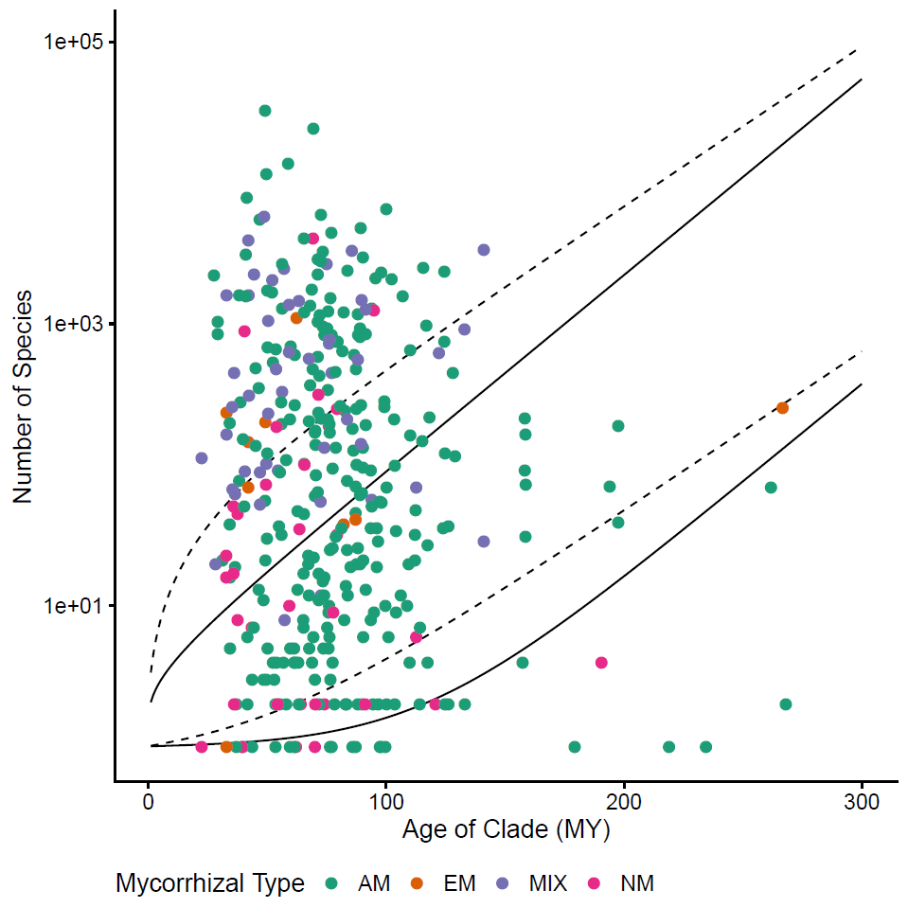

**Figure 2.**

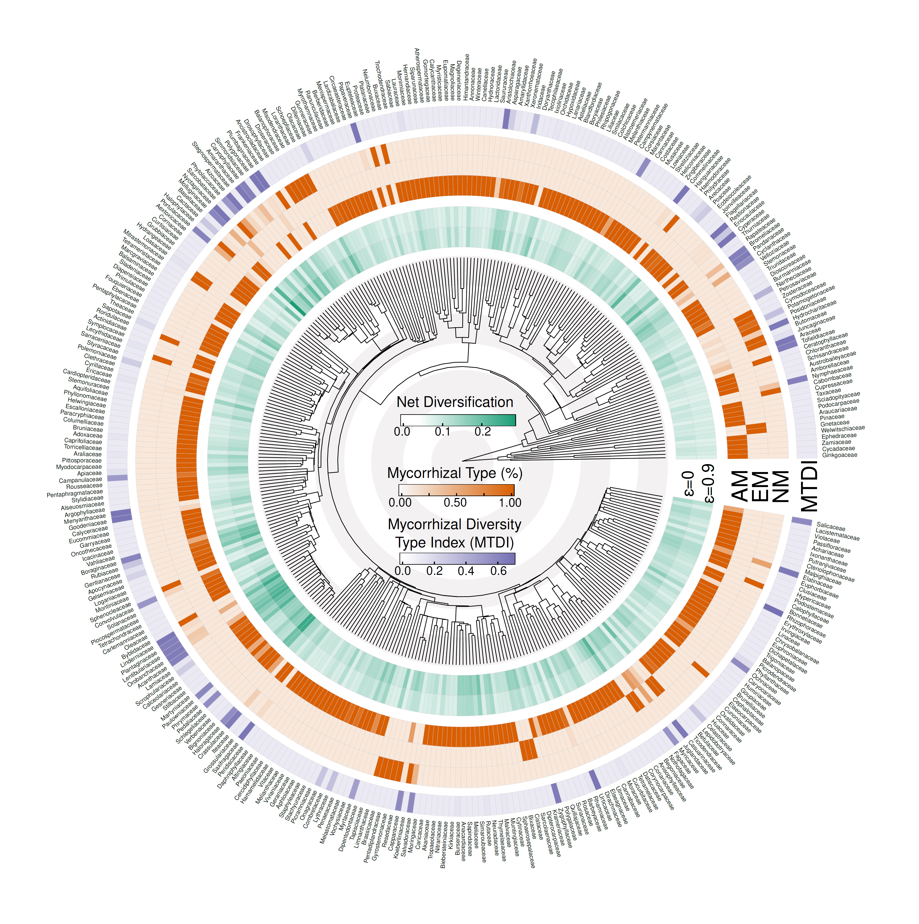

**Figure 3.**

**Macintosh HD:Users:tiagoquental:Downloads:boxplots_netdiv_myctype (1).pdf**

**Figure 4.**

**Macintosh HD:Users:tiagoquental:Downloads:scatterplots_lm_pgls_stem_edited (1).pdf**